Opinion: Gov. Matt Bevin sounded like a flailing loser after governor's debate
Al Cross, Opinion contributorPublished 10:23 a.m. ET Oct. 18, 2019 | Updated 12:52 p.m. ET Oct. 18, 2019
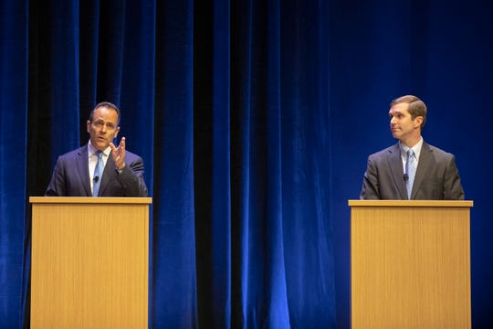
Republican Gov. Matt Bevin, left, and Democratic Attorney General Andy Beshear participate in a debate at the Singletary Center for the Arts on the University of Kentucky campus in Lexington, Ky., Tuesday, Oct. 15, 2019. (Ryan C. Hermens/Lexington Herald-Leader via AP, Pool) (Photo: Ryan C. Hermens, AP)
LEXINGTON, Ky. – Matt Bevin is a conviction politician; he has beliefs and sticks to them. That’s one thing to like about the governor. But some of his beliefs are mistaken, perhaps even about himself. That was on display Tuesday night at the University of Kentucky, after he and Attorney General Andy Beshear tangled in a televised debate.
Afterward, Beshear told reporters that Bevin was “unhinged” in their hourlong encounter. That description much better fit Bevin’s performance in his own press conference, which followed. He tried to rewrite his political history and made unsupported assertions about his questioners.
Bevin made perhaps his best-known remark on April 13, 2018, after the legislature controlled by his own party overrode his vetoes of tax and budget bills, amid a protest by teachers whose sickout caused many school districts to cancel classes on short notice.
He said, "I guarantee you somewhere in Kentucky today, a child was sexually assaulted that was left at home because there was nobody there to watch them. I guarantee you somewhere today, a child was physically harmed or ingested poison because they were left alone because a single parent didn’t have any money to take care of them."
Also: Personal attacks mark second governor debate between Matt Bevin, Andy Beshear
Kentucky's governor says children were physically harmed, poisoned, sexually assaulted, and tried drugs due to having the day off Friday.
The governor provided no proof that such calamities occurred, and his remarks sank him in job-approval polls. He has bounced back with scare-tactic ads about illegal immigration, and has pulled even with Beshear. He’s probably on track for reelection, as long as President Trump’s Kentucky approval rating doesn’t sink. But in that press conference, Bevin looked and sounded like a flailing loser. Asked about his damaging comment, he said:
“Do any of you truly believe that when children are left home unattended that bad things don’t happen to them? Do any of you really believe that? That’s what I said. I said when children are left home alone unattended, they’re exposed to drugs, they are sexually assaulted, that they’re exposed to things that are bad for them.”
No, Governor, that’s not what you said. You guaranteed that such things had happened. If, the day after, you had said that’s what you meant to say, and apologized, you might be assured of reelection right now. Instead of taking the blame, you put it on the news media, and you doubled down on that Tuesday night.
“Teachers were nowhere in that commentary; their names were never invoked,” Bevin said, adding later, “For people to then conflate that into saying it was a direct attack on them, and for you all to carry that water, which was an absolute, blatant lie ... get the actual question that was asked, and the full answer, and you will realize that what you’re alluding to and what you’re asking about is not based on anything I actually said. It’s based on falsehoods that many of you have reported, and that people enjoyed hearing, because it fit a narrative that they wanted.”
Asked if people are making up what they think he said, Bevin replied, "Perception is reality, and perception is driven by people not doing their homework sometimes to get to the truth — or, in fairness, you not reporting the things capable of allowing them to get to the truth, by holding out a question to an answer that wasn’t asked.”
The governor was way off base. The video of his remark begins with the question, “What did you think about the demonstration today by the teachers from across the state?”
Bevin ended Tuesday night’s presser by telling the reporters, “I know you’re voting for the other guy. ... You can continue to carry water for the next two and a half, three weeks, for those of you that are doing it, and you can ask half-baked things. ... But at the end of the day, the people of Kentucky deserve better than that. They deserve the truth, and for the next four years, you’re gonna realize that things are shifting, and you can either come along board and actually report on the news, or you can continue to try to twist and fabricate.”
Kentucky governor race: Where Andy Beshear and Matt Bevin stand on key issues
Bevin seems to believe that reporters play favorites, and those who ask him tough questions are out to get him. What they’re trying to get is the truth. That often requires asking for responses to an opponent’s charges, but beyond that, no one worthy of the job title reporter carries water for or against a politician.
Journalists are human; sometimes our feelings do show, especially when we’re disrespected. And it might even affect our votes. But we are trained to not let it affect our work, and editors and colleagues help us do that. We sometimes fall short, but we try to operate in good faith. Our leaders should, too.
Al Cross, a former Courier Journal political writer, is professor and director of the Institute for Rural Journalism and Community Issues at the University of Kentucky. He writes this column for the Kentucky Center for Public Service Journalism. Reach him on Twitter @ruralj.

