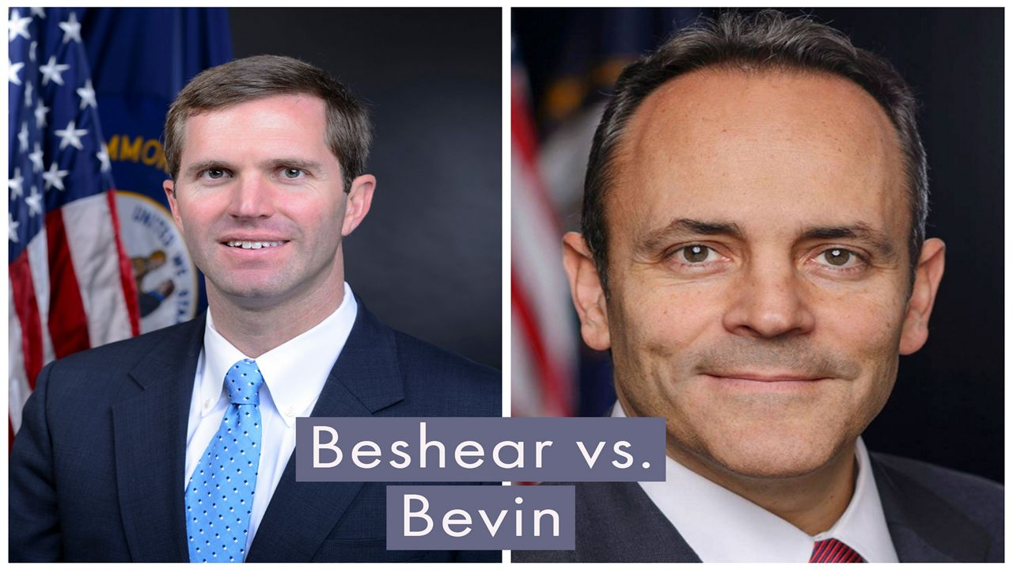
POLITICS

What the Gubernatorial Candidates Said on the Issues
BY JOE RAGUSA KENTUCKY
PUBLISHED 10:35 PM ET OCT. 15, 2019
Spectrum News 1
LEXINGTON, Ky. - The two men running for governor in Kentucky squared off in the second of five debates at the University of Kentucky, with both men drawing loud reactions from the crowd despite warnings from the moderators not to cheer or boo either candidate.
The Lexington chapter of The League of Women Voters and Gray Television stations WAVE and WKYT hosted the debate between Gov. Matt Bevin and Attorney General Andy Beshear on Tuesday night.
Moderators focused on several different topics, ranging from education funding to healthcare reform to abortion. Here’s a synopsis of what each candidate had to say:
EDUCATION
Beshear: “What we are going to do is end the bullying against our teachers we have seen the last four years. Then we’re going to provide a $2,000 across-the-board the raise that nobody has given our teachers. They have more than earned it. We are going address this teacher shortage where we have year-round subs teaching our kids in areas that are so critical to building into the next year and the next year. And we are going to have an “Education First” budget, where we always take care of public education first. Where we shrink our class sizes, provide technology to our kids that need it, and ensure our educators have the tools where they’re not doing more with less every year, they’re just doing more.”
Bevin: “The only solution to everything that we want is to have more people living in Kentucky working, which we have record levels of like never before, and paying taxes. There is no other solution. There’s no amount of gambling or pot smoking or promises or ‘Andy Candy’ that can be given to you all that’s going to cover this. The bottom line is: We need more taxpayers, more people here working.”
In his response to Beshear’s statement, Bevin said Beshear’s kids attend private schools.
“You’re attacking my kids now?” Beshear asked.
“No, I’m not,” Bevin responded. “I’m just saying you’re a fraud.”
After the debate, Beshear said he wasn’t surprised Bevin brought up his kids and accused him of attacking kids across the state with his policies.
“And then my opponent, who was unhinged and erratic tonight, he was angry and he showed that he is not fit to be governor.”
Bevin said he did not attack Beshear’s children; Instead, he was attacking Beshear’s decision to put his kids in private school.
“He sits there and blows a lot of smoke and you all give him a lot of cover as the champion of public schools, and he believes in them so much that his children have been in private school their entire lives? He is a fraud,” Bevin said.
ABORTION
Bevin: “The role of government is to protect the weak against the strong; The minority against the majority, the voiceless against those that have the bully pulpit. And it is the responsibility of government to defend the defenseless, and that includes the unborn. I’m unapologetically pro-life, unapologetically supportive of the unborn. I will not take money nor am I supported by Planned Parenthood, as is the pro-abortion opponent that I face. He’s also supported by NARAL, people who support abortion all the way up until birth.”
Beshear: “I support Roe v. Wade, but I also support the reasonable restrictions it allows, especially on late-term procedures, but this governor is an extremist. He supports a total ban, even for victims of rape and incest, something the president doesn’t support, nor does his attorney general candidate support. I work every day as attorney general with victims of human trafficking: Those that have been harmed and violated multiple times a day for years before we rescued them. I believe those people deserve options. This governor would leave them none.”
MEDICAID REFORM
The subject of Medicaid reform centered on a proposal Bevin which would subject Medicaid recipients to work requirements. The Trump Administration approved the plan last year but it was struck down by a federal judge. That judge’s decision is currently under appeal.
Bevin: “My thoughts as it relates to expanded Medicaid, the question, is to ensure that Medicaid is available for those who need it, and the medically frail and women with children and those that are disabled do not lose out because people like me are taking something that was never intended for them.”
Beshear: “Governor Bevin’s plan will rip 95,000 off health care that have it for the very first time and I think that’s wrong. And his plan is going to cost $272 million of our taxpayers dollars. That’s twice as much than four other states that are trying this put together. And when they did this in Arkansas, the vast majority of people who lost their coverage were already working. This is red tape. This is paperwork, and it is intended to tear healthcare away from people. I will always stand up against that and I’m going to rescind that Medicaid waiver in my first week of office.”

