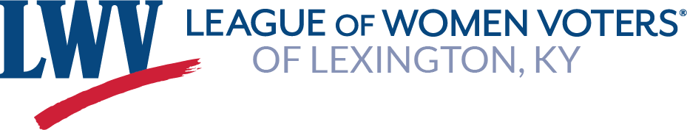

Lexington VOTER

Volume 19-20, Issue 3, October 2019

The Voter has a New Look!
The Lexington VOTER is published nine times a year (Summer, September, October, November, December, Winter, March, April and May) by the League of Women Voters of Lexington. With this October edition of the Lexington VOTER, you'll notice a new look.
Your fellow League members, trying to fill Judy Johnson's shoes, have found a way to make this task a bit easier by using a new format. Liz Sheehan and Liza Holland are very familiar with this platform and have agreed to take on the task of keeping you informed. We hope you like the new format and welcome your comments or questions at lwvlexvoter@gmail.com
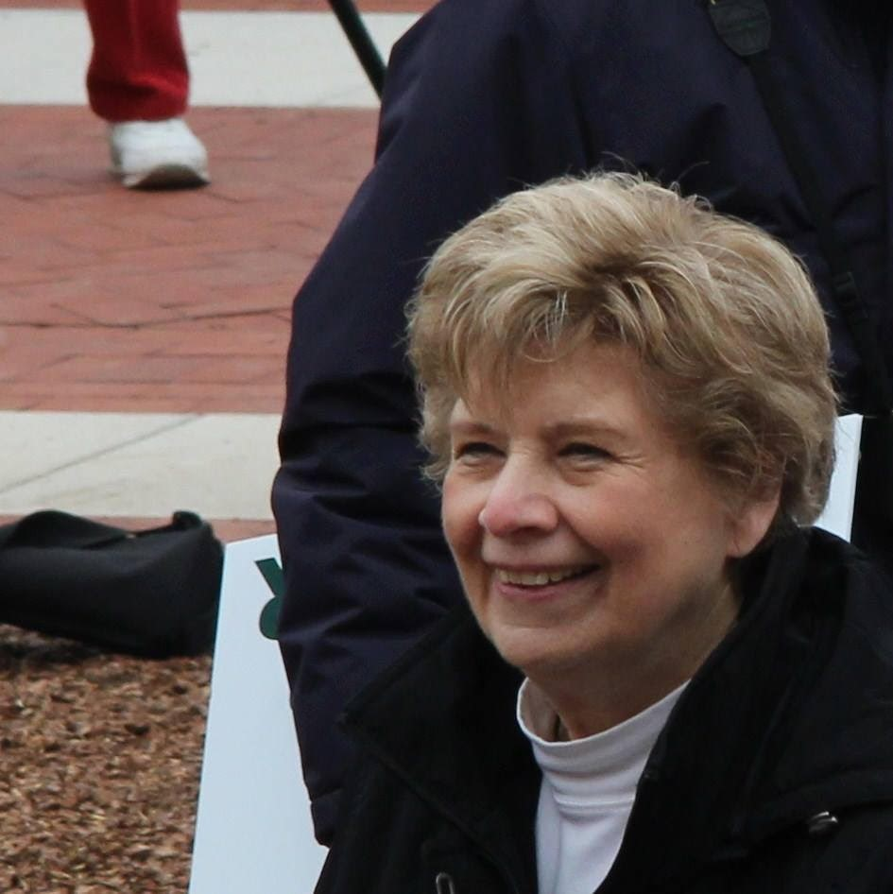

Judy Johnson (1939-2019)
By Barbara Sterrett

It is with great sadness that we report the death of Judy Johnson, one of the League of Women Voters of Lexington’s most active members. Judy was serving as second vice president of the Lexington League. Judy produced the League’s VOTER publication and took responsibility for the Essay Contest for many years. In addition to those large responsibilities, Judy served as a board member and chair of the Kentucky League committee to secure voting rights for persons convicted of felonies who have completed their full sentencing, registered voters, and volunteered whenever there was a need. Judy started her association with the League of Women Voters in Hot Springs, Arkansas. When she retired from her job as an educator in Fayette and Spencer Counties, Judy took on many Lexington League responsibilities. In addition, Judy was active in other community organizations. She volunteered as a tutor at the Carnegie Center, worked with B.U.I.L.D, and volunteered at the Kentucky Horse Park. Judy was always ready to listen to and aid her relatives, friends and acquaintances. We will miss her deeply.
There will be a celebration of Judy’s life on 20 October 2019. Join those who valued Judy and have an opportunity to honor Judy’s contributions to the League and the community. Check in at the email: WeCelebrateJudysLife@gmail.com to receive updates about the event.
Her full obituary can be found at:
https://www.legacy.com/obituaries/kentucky/obituary.aspx?n=judith-lynn-cowan-johnson&pid=193967552

The League’s online voter guide, VOTE411.org will go live October 8. It can be accessed on cell phones, laptops and tablets, a good and easy way for citizens to learn about the statewide candidates for Constitutional offices. VOTE411 offers a 'job description' for each of the state offices and responses of candidates who choose to respond to our questions. It also allows citizens to register to vote, check their voter registration status and check their polling location.

Sept 15 Community Forum on Opioids with Andrea James
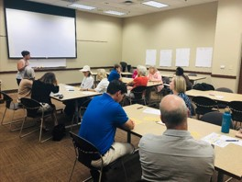
Andrea James, Special Projects Coordinator from Mayor Gorton's office, presented updates on her work on the opioid crisis and facilitated small group discussions on what we can do in the community to reduce the stigma around addiction, dispose of medications, educate the community on opioid use and substance use, and adopt successful programs from other
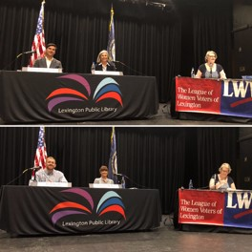
communities. Andrea recommended that everyone do the Narcan training offered by the Health Department.

Sept 29 Candidate Forum
The Lexington LWV hosted forums on
September 29 for two local races held to fill
vacancies on the school board and the Circuit
Court. Citizens were able to meet the candidates
and submit questions. Our co-sponsor, the
Lexington Public Library, hosted the forums in
their Main Branch library and videotaped the
forums for public viewing on YouTube, which you
can find on our
website:
htt
ps://www.lwvlexin
g
ton.com
/
October 15 Gubernatorial Debate in Lexington SOLD OUT
A televised debate for the office of governor of Kentucky will be held on the University of Kentucky’s campus Tuesday, October 15, in the Singletary Center for the Arts. Candidates Gov. Matt Bevin and Attorney General Andy Beshear have confirmed their participation in the event co-sponsored by the UK Student Government Association (SGA), the
League of Women Voters of Kentucky and Gray Television and its TV stations serving Kentucky.

Tickets for this debate are sold out! However, the debate will be broadcast LIVE from 7 to 8 p.m. Eastern Time and 6 to 7 p.m. Central Time on the following Gray Television stations: WKYT in Lexington; WAVE in Louisville; WBKO-FOX in Bowling Green; WYMT in Hazard; and TriState's CW in Huntington, West Virginia.

The debate will also be livestreamed on the following TV stations' websites: WBKO in Bowling Green; KFVS in Cape Girardeau, Missouri; WXIX in Cincinnati; WFIE in Evansville, Indiana; WVLT in Knoxville, Tennessee; WYMT in Hazard; WSAZ in Huntington; WKYT in Lexington; and WAVE in Louisville. The debate will be available after the fact at WKYT.com with links at lwvky.org.

Moderators for the event are news anchors Bill Bryant of WKYT and Shannon Cogan of WAVE. The League of Women Voters of Kentucky's nonpartisan policies will be followed, and questions for the candidates have been developed by the sponsors and solicited from college students across the Commonwealth.

Libertarian Candidate, John Hicks, did not meet the League’s requirement for participation of 5 percent or more voter recognition on nonpartisan polls and was not invited to participate.

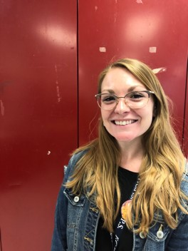
LWV nominates Fayette

County Teacher for Harvard civics workshop
The Lexington League nominated Lafayette High School U. S. History teacher Stevie Lemons for participation in a Harvard University workshop August 18-20 on the use of case study methods to teach high school civics. The workshop was taught by Professor David Moss of Harvard Business School, who pioneered the Harvard Case Study Method to teach U. S. history, democracy and civics. Last summer, the Business School partnered with the LWV of Greenwich, CT to offer the workshop to local high school teachers selected by the League. This pilot effort was so successful that the national LWV invited individual League chapters to nominate 1-2 outstanding teachers from their local districts to participate in the 2019 workshop.
The LWV of Lexington selected Ms. Lemons based on an essay about her passion for civic engagement, followed by a phone interview. The final step in the selection process was an interview with the Harvard Case Method Project Team.
The 2 ½ day workshop engaged teachers in intensive study of key episodes of US History including the writing of the Constitution, division over slavery, and concepts of justice and liberty throughout our history. Ms. Lemons said, “The Case Method is all about using discussion and questioning as the basis of learning. The theory says students will not only learn better but they will retain more and be engaged in class and with the content. This will affect my teaching practices positively and also assist with implementing the new inquiry-based Kentucky standards for social studies content.”

In addition, she said that she recently taught her first case study and her students loved it! “All of them were engaged in the class discussion, each of them having a lot to say,” she said. “After the class they told me they felt like they really knew the content and could write an entire essay on the topic.” She also said several students really enjoyed being able to share their thoughts and opinions because it made the class more interesting.

Ms. Lemons highly encourages any teacher who is interested in the method to apply for the Harvard team’s next workshop. Former League member Judy Johnson took the initiative on this project for the Lexington League, contacting the schools and working to identify candidates. Contact Ms. Lemons at stevie.lemons@fayette.kyschools.us or 606-304-5577
League of Women Voters Sponsors Annual Essay Contest for Teens

The League of Women Voters of Lexington has invited all Fayette County 9th-12thgrade social studies/history teachers to encourage their students to participate in the League’s annual Jay Ogden Essay Contest. Invitations went to public and private schools, as well as to homeschooling associations.

This year’s prompt encourages students to develop their understanding of why U.S. eligible young voters (ages 18-29) have lower voting rates than older voters. Participation in the contest requires research as well as discussion of the issue with peers. The goal is to help prepare our students to be informed citizens who understand the value of voter participation.

Winning students receive $250 for 1st place, $150 for 2nd place, $100 for 3rd place, and $100 for ESL writing special recognition. As well, a small honorarium is awarded to the teacher/sponsor of each winning writer. Essays are due by
December 6, 2019, with awards presented in February, 2020. Should you have any
questions about the contest, please email Theresa McCarty at lwvlexessay@gmail.com.

Want to support the work of LWV of Lexington, KY? Go to our website (lwvlexington.com) to become a member or to sign up as a volunteer for one of our events!

Upcoming Events

October 7: Last day to register to vote for the election on Nov 5th. Register by 4 PM.
October 8: Wendell Ford Lecture Series: The Increasing Role of Women in Public Policy, Featuring former Kansas Governor and HHS Secretary Kathleen Sebelius, journalist Margaret Carlson, and Mayor Linda Gorton. 4PM, Worsham Cinema in UK Gatton Student Center, Free and Open to the Public
October 15: Gubernatorial Debate in Lexington (SOLD OUT) 7-8 PM; watch at WKYT.com.
October 17: Connie Griffith Manor, Get Out the Vote booth. 10-
11:30 https://signup.com/go/qzmochX
October 19: The Henry Clay Center for Statesmanship, College Summit on
Kentucky Pensions. 9 AM-11:30 AM Gatton College of Business and Economics. LWV booth 8:30-12. Also need a volunteer to be a Policy Judge. 9-11:30. Details on the website. Sign up: https://signup.com/go/osZWqcE
October 22: Book Club, The Pioneers by David McCullough, contact Terry Naydan, TerryNayden@aol.com
October 26: Gubernatorial Debate in Louisville
October 26: Christian/Muslim Dialogues, 10AM Christ Church Cathedral, 166 Market
Street, parking behind the church
November 5: Election Day! Polls open 6AM - 6PM.
November 6: LWV Lexington Board Meeting, 6:30-8PM, open to the public!
November 15: Naturalization Ceremony, US District Courthouse 101 Barr Street. 11
AM-12:30 PM, arrive 10:40. Sign Up: https://signup.com/go/FFcGFAU
November 17: Civic Education Community Forum, featuring Stevie Lemons and
Carly Muetterties, 2:30-4:30 PM at Village Branch Library

